Acceptance tests   
“Acme Rookies v1.0”

|  |  |
| --- | --- |
| Development team | |
| **Identifier** | *G92* |
| **Members** | *Batista Núñez, Francisco.*  *de la Flor Bonilla, Álvaro.*  *Fernández Benjumea, Carmen.*  *Ferrete Molle, José Antonio.*  *Salvat Pérez, Antonio Manuel.*  *Sanchez Hipona, Antonio.* |
| **Testing team** | |
| **Identifier** |  |
| **Members** |  |
| **Indexing data** | |
| **Test designers** | *Salvat Pérez, Antonio Manuel.*  *If you need to contact me:*  *antoniosalvatperez@gmail.com*  *+34 673 53 28 89* |
| **Testers** |  |
| **Notes** | *Use cases of R23.1* |

**Table of contents**

Use case 24.1: Logged , social profile 3

# Use case 24.1: Logged , social profile

Description

Manage his or her social profiles, which includes listing, showing, creating, updating, and deleting them.

Access

First, the user must log in the login page. User: company, Password: company

The steps to follow are explained down.

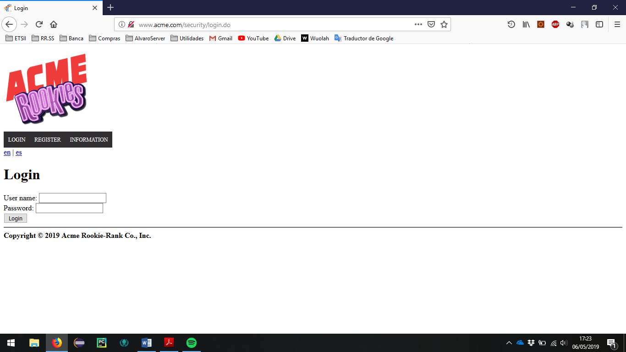

Go to the section of user profile.

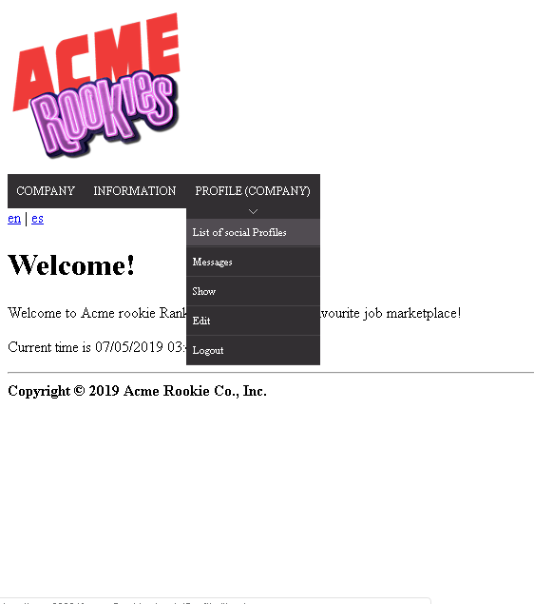

> Header Menu > Display the "PROFILE" options > List of social profiles

The list of social profiles should appear. The list is empty because there aren´t social profiles in the populate.

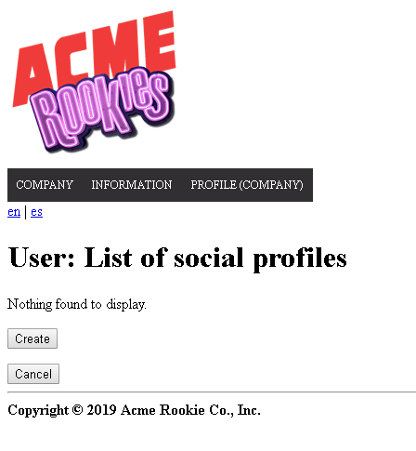

The user must click on the button “create” to redirect to the view of create a social profile. In this view we find three fields, one for the name, one for the link, and one for the nick.

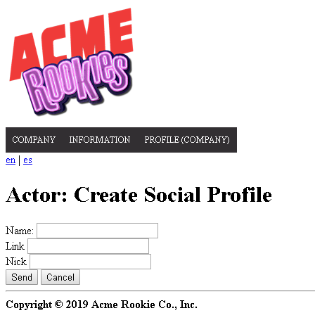

Tests

|  |  |
| --- | --- |
| Test 1 | |
| **Description** | Click on the button to create a new message and fill it with invalid data. |
| **Expected** | A form with 3 fields must appear, being the 3 completeness mandatory.  After sending will be redirect to complete the field |
| **Outcome** |  |
| **Notes** |  |

|  |  |
| --- | --- |
| Test 2 | |
| **Description** | Re-complete the previous form but with valid data. |
| **Expected** | If all the fields have been completed correctly the system will create the social profilesand redirect to the list view of the social profiles.  Make sure that all the fields are correct.  Link is a url. |
| **Outcome** |  |
| **Notes** |  |

|  |  |
| --- | --- |
| Test 3 | |
| **Description** | Correct listing. |
| **Expected** | Check that the list of social profiles is correct |
| **Outcome** |  |
| **Notes** |  |

|  |  |
| --- | --- |
| Test 4 | |
| **Description** | Show social profile |
| **Expected** | Click the name to redirect to the show view |
| **Outcome** |  |
| **Notes** |  |
|  |  |

|  |  |
| --- | --- |
| Test 5 | |
| **Description** | Edit social profile |
| **Expected** | In the list of social profiles where you click edit the social profile ypu enter in the view of edit |
| **Outcome** |  |
| **Notes** |  |

|  |  |
| --- | --- |
| Test 6 | |
| **Description** | Delete social profile |
| **Expected** | In the list of social profiles where you click delete the social profile will be remove from the system. |
| **Outcome** |  |
| **Notes** |  |